

Asia Pacific College

School of Computing and Information Technology

System Analysis and Detailed Design

**SM Hotels Service Request Management System**

Submitted by:

Lurenne Tangi

Project Manager

Kenneth Abuel

Project Developer

Submitted to:

Ms. Maricel P. Naviamos

Professor

Date:

8/31/2017

Table of Contents

Project Title 1

Executive Summary 3

List of Figures, List of Tables, List of Notations 4

I. Introduction 5

1.1 Project Context 5

1.2 Purpose and Description 5

1.3 Objectives 5

1.4 Scope and Limitations 5

II. Review of Related Literature/Systems 5

III. Technical Background 5

IV. Methodology, Results and Discussion 5

4.1 Requirements Analysis 5

4.2 Requirements Documentation 5

4.3 Gap Analysis/Needs Assessment 5

4.4 Design of Software, Systems, Product, and/or Processes 5

V. Conclusions and Recommendations 5

VI. Appendices 6

**Executive Summary**

Our client tells us that they are using Microsoft Excel to accept the request of the Hotel Guest. The team thinks that they needed us to change the system they’re using. Our system has different functions that can make the Request department use it easier. Our system is more detailed, more user friendly and easier to use than Microsoft Excel that they are using currently.

Our client also needs a web based system that is actually related to our system that uses Web based system and not required to use a Mobile app. So our team thinks that our system will be a good match for their needs so they can work a lot easier than before.

# **List of Figures, List of Tables, List of Notations\**

1. Context Diagram
2. Diagram Level 0
3. Diagram Level 1
4. ERD Diagram
5. Activity Diagram
6. Use- Case Diagram
7. Data Dictionary
8. Gantt chart and WBS

**CHAPTER I**

**Introduction**

* 1. Project Context

Shoemart Hotels and Conventions Corporation was established to address the vast potential of tourism in the country. It is now developing and operating hotels and convention centers all throughout the archipelago with a current portfolio of 1,514 rooms housed in the Taal Vista Hotel, Pico Sands Hotel, Park Inn by Radisson in Davao, Park Inn by Radisson in Clark and a deluxe 5-star hotel, Conrad Manila, located at Mall Of Asia Complex. (SM Prime, 2016) All these allow guests to experience luxury and the world-renowned Filipino hospitality, made more memorable by the natural beauty. Also SHMCC operates convention centers and trade halls through SMX Convention Center, which has become a popular venue for both locals and international events.

When it comes to having an efficiency and a better performance in a hotel management, upgrading to a Hotel Management System is an excellent way to do because hotels can no longer achieve best service by relying on spreadsheets or old software.

Hotel Service Management system would provide the employees an ease of work and providing a better experience to the customers because the Service Request Management System can automate the handling of guest requests and maintenance jobs, thus ensuring high quality service and high staff productivity.

* 1. Purpose and Description

The team’s purpose are to identify what are the features of the current system, the problems of the customer service department that they are experiencing in delivering service management and to find a way on how the hotel are going to provide a better way of having a service management.

The team also need to focus on problems that the hotels encounter while providing service management in order to develop the most suitable hotel service management system that they need so that it would reduce service management errors and hotel’s customer service department will have more efficient way of servicing their hotel guest

* 1. Objectives

The team’s objective throughout the project time:

* To develop an automated system that will handle the service request of the hotel guest.
* To develop an automated system that will automatically allocate the guest service request.
* To generate a summary report of the service request that will help to find what are the usual problems that the hotel encounters.
* To have an organize list of service requested details that will minimize delays of the requested service and wrong requested item deliveries.
  1. Scope and Limitations

The scope of the study will focus on customer service department and also will be focusing on the automation of service request by having an automated system that will improve the way of providing service management in SM Hotels. The study is limited only to the customer service department of the hotel and it only covers the request and reports processing of the hotel guests.

**CHAPTER II**

**Review of Related Systems**

**2.0 Requested Systems**

Other companies are using automated systems for their hotels and convention systems, automated systems help to facilitate the hotel and conventions management and their personnel all through a single piece of software. This automated system can replace the old-fashioned paper based methods that can slow the process of the hotel and convention centers. There are several systems that can be used as a reference for the project.

Know Service can automate the handling of guest’s requests, complaints and the maintenance jobs, thus ensuring high quality service and high staff productivity. They also have the same function that we will use in our proposed system because the requests details are logged in either by hotel staff by the guests using an interactive guest application.

Opera Property Management System is a comprehensive and scalable solution that comes in three levels (Premium, Standard, and Lite) and also available for both cloud and installed deployment. The system also provides the same function as the Know Service but also include more functions that can be used in improving the Hotel Management.

Hotelogix, developed specifically for small and mid-sized hotels, it has a single-point dashboard, multi-device booking engine and third-party integrations with OTA’s such as TripAdvisor. The Hotelogix provides a better interface to work in that allows Hotels staff to be more productive. It handles the automated system that can allocate the guest’s request.

eZee Frontdesk by eZee Technosys, this system is used by boutique hotels, hostels/lodges, resorts and small hotels. This automated system is focusing on bookings reservation management system but it also has had a rate management that tracks the inventory of the hotel. Aside from booking, it also features the allocation of request service.

roomMaster by InnQuest, this automated system can be used by any types of hotel sizes. It has a complete audit trail for all financial transactions also with a PCI compliant payment processing while having a rate options. roomMaster can run in standalone or networked, it is far more than just another booking engine. It has been designed to help increase revenue and provide guests with great service from the moment they consider making a reservation, all at fraction of the cost of a third-party booking engine with the benefit of strong integration to roomMaster. It also features the allocation of request service.

MSI CloudPM developed by MSI, this system is a cloud based that is great for hotels looking to keep costs down by bypassing the purchase of additional hardware, it can automatically backup the files while having an optional backup. CloudPM saves money by eliminating capital expenditures for property technology, increasing the operating efficiencies and eliminating pricey on-property hardware requirements. It also features the allocation of request service.

Frontdesk is one of the most popular system for hotels because of having an easy to use interface, customizable availability calendar and having a personalized profile for their guests and travel agent. With a one simple screen, it provides everything you need. Check availability and rates, create amend reservations and take payments in a few clicks. Collect relevant information with personalized guests, company and travel agent profiles thus you can export the data to run marketing campaigns. It also features the allocation of request service.

Hostpos was created by the HostPms.com, the company runs a well-established customer based installed. The work is organized around a common project that reunites all necessary resources which are totally guaranteed by the business areas in order to be able to give the client best expectations. Hostpos has a very simple and efficient work area which allows the user to quickly perform different types of functions on one or more client accounts, it offers a large variety of settings that can be customized according to the customer’s needs; this may range from a single unit management to multi-unit control. It also features the allocation of request service.

Rezlynx PMS is a fully configurable, PCI compliant property management system to enable any sized hotel or group to manage their bookings and operations efficiently and profitably. The cloud hosted software provides a range of modules integrated into one system with interfaces to leading OTAs, Global Distribution Systems (GDS), other Guestline solutions and third party systems. It is updated in real-time, and incorporates full functionality, including a comprehensive rate and availability management tool to ensure that revenue is maximized at every opportunity. It also features the allocation of request service.

RDPWin was created by resortdata that can consequently send messages to all visitors, proprietors, travel specialists and gatherings who reserve a spot. These affirmations can be totally redone for the coveted data and appearance. Any framework report can be sent by means of email to a man or gathering in your address book. For instance, email the day by day administrators answer to a gathering of ten directors with only one process. It also features the allocation of request service.

Maestro PMS was created by Maestro that has risen as a top level arrangement supplier of hotel innovation arrangements and prides itself on an extraordinary customer mind benefit record that has for quite some time been perceived for giving customers the innovation arrangements that fit both their operational and administration needs. Maestro was first to showcase with a completely incorporated Windows PMS and Deals and Cooking arrangement, and is proceeding with that pattern with driving edge web and portable based arrangements. It also features the allocation of request service.

Skyware Hospitality Solutions, serving the hospitality industry with 24/7 service and state-of-the-art technology, is widely recognized for providing hotels, resorts, and management companies with flexible software solutions. Skyware is a leader in advanced software tools for hotel owners and operators who need to manage their business in a real time environment for efficient operational control and profitability. Skyware's modules can be customized to fit the specific needs of a property. It also features the allocation of request service.

Hoteliga is a cloud-based inn administration framework that enables you to perform effortlessly the day by day elements of your lodging. The simplest approach to deal with your reservations, simple set up in only a couple of minutes! Intelligent reservations logbook. Valuable reports with outwardly engaging diagrams. Invoicing and income control. Client administration. Booking offices contracts Value records and installments in various monetary standards. Programmed association with the most famous on-line booking stages. It also features the allocation of request service.

Cloud-based property management system with a booking engine and channel management. Also has a range of additional modules to increase the efficiency of your hotel management. Clock PMS is a new generation all-round digital platform for hotel management. It comes with the widest range of guest-facing features and engagement tools, along with fully automated online distribution, rate intelligence, and hotel F&B POS solution. It is ideal for independent accommodation providers, hotel groups, golf or spa resorts, city hotels, serviced apartments, and hostels and similar. It also features the allocation of request service.

Elina is the Property Management Platform for Serviced Apartments and Independent & Boutique Hotels, with a property management system at the centre. Elina provides you with a full set of Property Management, Revenue, Marketing and Sales Management tools as well as Stakeholder Management and Reporting and Analytics, enabling you to spend less time on daily operations, and spend more time with your guests and growing your business. It also features the allocation of request service.

Genkan is a complete cloud based solution for holiday rental, short term and vacation property management. The solution incorporates all the required tools such as email and SMS Marketing, Inventory management, trust accounting, Survey, payment gateways, inspections in one 'Real Time' software solution plus being multi lingual and multi-currency. Real estate agents and holiday rental managers who are in the business of managing short term and holiday vacation short term rental property. It also features the allocation of request service.

Cloudbeds connects your property to hundreds of channels with real-time, two-way integration. We are the no-sweat, all-in-one hotel management system that makes you more money, saves time, and makes guests happier. It works best for small to medium-sized independent property owners including but not limited to, hotels, hostels, bed and breakfasts, inns, vacation rentals, apartments, campgrounds and more. It also features the allocation of request service.

RezOvation Web is the leading web-based Bed & Breakfast software designed to provide Innkeepers with the tools to save them time, increase their occupancy, and provide them with the freedom and peace of mind to run their business online securely from anywhere. It also features the allocation of request service.

KWHotel is a hotel management software designed for small and medium accommodation facilities. This is suited for hotels, hostels, B&B’s villas and any other small – medium accommodation facilities. It also features the allocation of request service.

Bookalet is an online booking management system for owners and agents to manage every aspect of renting out holiday accommodations. It is used for vacation and holiday rentals. It also features the allocation of request service.

Magna Timeshare Software or enterprise timeshare software for timeshare resorts with ASP or server on-site models. Sales automation, tour appointment automation, minivac management, sales contracts, tour commissions, OPC commissions, sales commissions, mortgage and finance automation and management, Real-time web based reports, statistical reports, and KPI reports. Sistem Otel PMS is an on premise hotel management solution for hotel businesses of all sizes. The solution is compatible with windows operating systems and offers support for multiple languages. Hotel software includes sales, reservation, cashier, POS, front desk and back office modules for hotels and hotel chains. It also features the allocation of request service.

Open Hotel PMS is working independent properties since 1999. US base d with US support. Drag & Drop reservations, Housekeeping/Maintenance can update room status from mobile devices, customizable reports including source/marketing codes, forecasting, RevPar, and Gopar, one click check-in, Built in email marketing, automated pre and post reservation emails. The one who uses this are small and mid-size properties of all types that are looking for a robust solution that is easy to use, learn and implement. We will be with you every step of the way. It also features the allocation of request service.

Smart Hotel Software is a full featured Hotel Property Management Software Solution for hotels and resorts. - Revolutionary integrations that work the way software should work. - Commission free online booking that bolts onto your own website. - Unlimited 24/7 technical support-get a real person on the phone! - Flexibility to manage your unique situations. Point of sale, accounting, housekeeping, maintenance, spa, meeting rooms, and much more. Prices start at $5,000 for everything. It also features the allocation of request service.

The All-in-One PMS Solution ibelsa is a web-based hotel management software for all kinds of accommodation facilities and enables the user to easily navigate through the various processes involved in running a hotel from all over in the world. ibelsa forms the centerpiece for the management of any hotel, allowing access to all internal hotel data, as well as all third party systems, such as POS, channel manager, TV systems and door locking system. Hotels, Hostels, Motels, Guesthouses, Apartment renting, Apart-Hotels, Housing-Tourism/Apartment, Camping. Hospitality Management is a comprehensive software system for management of Hotels, Resorts, Motels and Inns. Ease of use and a comprehensive set of features are the hallmark of this software. This software system offers clients a unique opportunity to benefit from computerization in a quick and cost effective manner. It also features the allocation of request service.

Rezserve helps you manage listings, rates, availability, and clients through one platform. It offers software and digital solutions for the travel industry, our main clients are boutique hotels, property management business and tour providers. It also features the allocation of request service.

iRez Systems has developed a reservations system that is openly definable and customizable to match your unique and specific business needs. Rezware has easy to use state of the art features developed with industry standard tools, for a variety of platforms ranging from multi-user Windows based computers, to internet, and enterprise based reservations capabilities. It also features the allocation of request service.

Hotel Management is highly integrated that can help hotels automate the entire gamut of operations with maximum ease. Monk HMS is suitable for small midsize large and group of hotels also resorts boutique hotels. It also features the allocation of request service.

WinHMS Express is created by Winsar Infosoft that uses by Hotels Lodge Resorts Guest house SPA Golf Banquet Motels. It is easy to use and intuitive in every way. WINHMS aims at simplifying and speeding up hotel management and accounting needs. It also features the allocation of request service.

RezEasy Cloud PMS & Booking Engine is a powerful web based Property Management System designed to meet all of your front and back office needs. Includes commission-free Booking Engine &Agent/Corporate Client module. The system is mobile-friendly and includes a mobile optimized booking engine plus PC and Tablet interfaces for the Front Desk system. It also features the allocation of request service.

I-Pro Booking System are experts in the vacation rental industry providing a streamlined solution to allow you to manage your rental business whether you have 1 property or over 500 properties. Track Leads, Manage Bookings via phone, email or online, manage payments, invoices. It also features the allocation of request service.

Corrigo CMMS property management is created by Corrigo that is used in commercial property management, residential property management, hospitality property management, parking management, and municipal properties. Corrigo also accepting a request from the hotel guest.

Mirage Hotel systems is completely integrated property management solution for hotels, motels, inns, and resorts. It also features the allocation of request service.

Guardian is created by ofek technologies that is fully integrated suite of hotel automation products consisting of modules that can be easily added or expanded. It also features the allocation of request service.

Protel PMS is used by innovative hotels, from large multi-site to smaller independents, who rely on technology to do most of the heavy-lifting in their daily operations. We have ideal product variations for all-comers. This is an all-in-one hotel management solution from small individual hotels to large international hotel chains. It also features the allocation of request service.

HoteloPro is a web-based hotel management solution built specifically for small hotels, inns, bed and breakfasts (B&Bs), guest houses, and vacation apartments. HoteloPro makes it easy for small hoteliers to organize their business, save time, and acquire more clients. It is used by small hotels, inns, bed and breakfasts (B&B’s), guest houses, and vacation rentals. It also features the allocation of request service.

Hospitality property management solution offering full front of house features and reporting, room management, E-POS, menu costing, stock control, Inventory and asset management, full accounting and reporting all seamlessly integrated into one user friendly, real time effective system. It is an ideal solution for SME property owners and managers wanting to have real time access to reports on the various aspects of their business for informed decision making. It also features the allocation of request service.

SMS|Host is created by Springer-Miller Systems that is used by Luxury Hotels and Resorts Mountain and Ski resorts condo timeshare hotel golf resort beach resort wellness resorts and retreats. It also features the allocation of request service.

Resort Manager is created by Little Fish Technologies which is used by Hospitality industry including Villas, Hotels, Resorts, Restaurants, Boutiques and other retail outlets. This is a premium one-stop solution for all operational system needs for small/medium-sized hotels, villa complexes, golf courses and resorts. It also features the allocation of request service.

Guest Centrix is a flexible and tailorable hospitality property management solution for hotels and resorts of all sizes. It also features the allocation of request service.

Clerk is the perfect online tool designed for hotel management in the cloud. Keep track of your hotel from anywhere. Nice and Simple. It allows people to manage bookings, stays, arrivals, departures, closing sales, and all the important operations of your hotel, quickly and efficiently, so you can spend less time managing and more time paying attention to your customers. It also features the allocation of request service.

Innkey PMS is the next generation property management system, which automates your business with an easy-to-use enterprise platform that provides centralized controls and reporting while enabling each property to run at maximum efficiency. It also features the allocation of request service.

ManCloud offers an unseen flexibility. It's a real-time modulair platform that can be tailored to your needs. By offering the system as a service with a monthly fee, the investment is very limited and spread into time. Additionally, you can freely choose the hard- and software you use. (PC, MAC, Linux, Windows) Because ManCloud is web-based, you just need in internet connection on your device. ManCloud has a wide range of integrated modules that help you organise in to perfection. It also features the allocation of request service.

**CHAPTER III**

**Technical Background**

1. **Software Requirements:**

**Google Chrome**

Chrome is a free Internet browser officially released by Google. Chrome offers tight integration with Google sites and services, such as YouTube and Gmail, and manages its system resources differently than other browsers. Its V8 JavaScript engine was developed from scratch at Google, and may improve experience on script-heavy websites and applications.

**Mozilla Firefox**

Firefox supports most basic Web standards including HTML, XML, XHTML, CSS (with extensions), JavaScript, DOM, MathML, SVG, XSLT and XPath.

**Yii Framework**

Yii is a high-performance, component-based PHP framework for developing large-scale Web applications rapidly. It enables maximum reusability in Web programming and can significantly accelerate your Web application development process.

**Windows OS**

The most widely used operating system for desktop and laptop computers. Developed by Microsoft, Windows primarily runs on x86-based computers. Windows provides a graphical user interface and desktop environment in which applications are displayed in resizable, movable windows on screen.

**PHP**

PHP is a server-side-scripting language designed primarily for web development but also used as a general-purpose programming language. PHP code may be embedded into [HTML](https://en.wikipedia.org/wiki/HTML) or HTML5 [markup](https://en.wikipedia.org/wiki/Markup_language), or it can be used in combination with various [web template systems](https://en.wikipedia.org/wiki/Web_template_system), web content management systems and web frameworks.

**MySQL**

For our Database we will useMySQL, it is a free, open-source database management system that has been around for years. It is very stable and has a big community that helps maintain, debug and upgrade it

1. **Hardware Requirements:**

**Computer**

A computer will be the device that would be used to access the implemented automated system. The minimum requirements were based on the research that the researchers made.

Computer

Operating System : Windows 7 or higher

Processor : Dual-core 2.5 GHz

RAM : 2GB

Internal Storage : Minimum of 500GB

**CHAPTER IV**

**Methodology**

**4.1 Context Diagram**

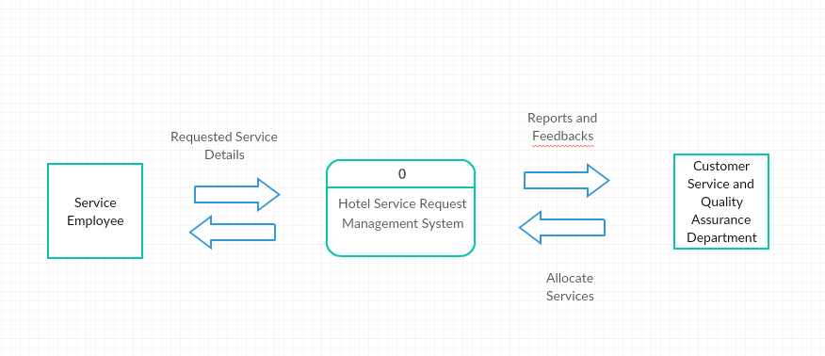

Figure 1: Context Data Flow Diagram for the SM Hotels Service Request Management System

The Context Diagram shows the participants who will interact with the system. There are only two entities that will interact to the system. When the Hotel Guest calls to the Customer Service Department, the Service Employee will input the requested service details in the system while the Customer Service Department staff will check the availability of the Service Employees then the requested service will be allocated. The Quality Assurance Department can also view the summary reports provided by the Service Employee.

**4.1.1 Diagram Level 0**

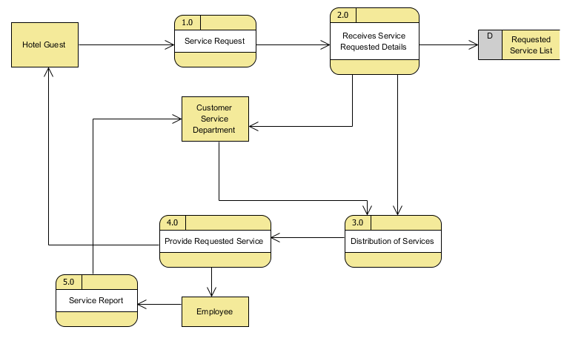

Figure 1.1: Diagram Level 0 for the SM Hotels Service Request Management

The Diagram Level 0 shows that when the Hotel Guest makes a request, the requested service details will be received by the Customer Service Department and the details will be recorded into the system. The Customer Service Department staff will find an available Service Employee then the staff will allocate the service to the assigned Service Employee then the requested service will be provided to the Hotel Guest. After the service requested has been provided the employee will provided a summary report for the Customer Service and Quality Assurance Department.

**4.1 2 Diagram Level 3**

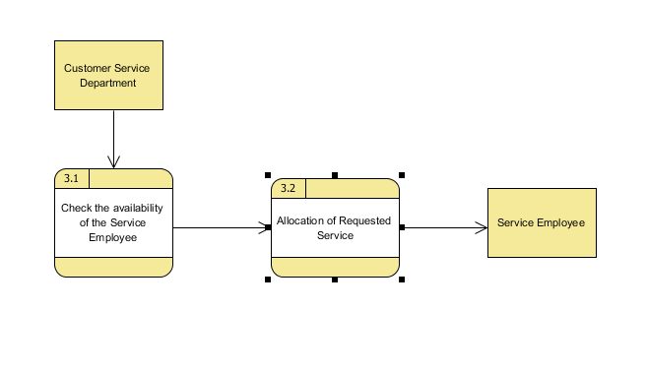

Figure 1.2: Level 1 Diagram

Figure 1.2 shows the process of allocation of services that will be provided for the request of the hotel guest. After the Customer Service Department prepares the service requested, they will check first the availability of their Service Employee if there is someone who is available then they will allocate the requested service to the Service Employee.

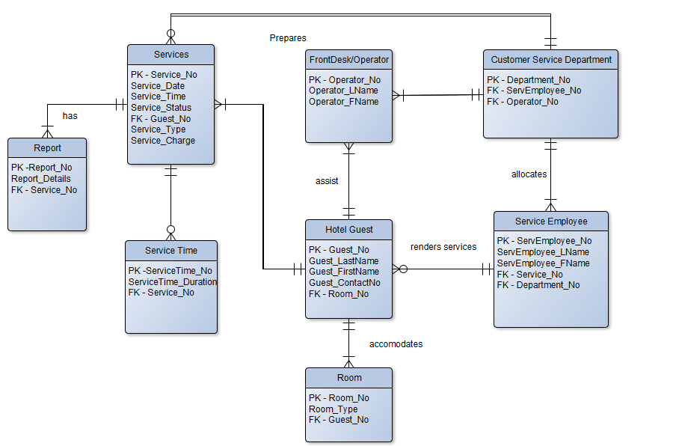**4.2 Entity Relationship Diagram**

Figure 2: Entity Relationship Diagram of the SM Hotels Service Request Management System

The Entity Relationship Diagram consist of 7 entities, the Hotel Guest accommodates a room and can request a service by calling the front desk through the provide phones in their rooms. The Front desk employees are the ones who will assist the hotel guest if they requested for something, the front desk will redirect the service requested information to the customer service department and the customer service department are the one who will allocate the service requested by the hotel guest to an available service employee. The service employee will render the service requested by the hotel guest.

**4.3 Data Dictionary for the Entity Relationship Diagram**

|  |  |  |  |  |
| --- | --- | --- | --- | --- |
| Table Name | Attribute Name | Contents | Type | PK OR FK |
| Frontdesk | Operator_No Operator_LName Operator_FName | Operator Number Operator Last Name Operator First Name | INT  VARCHAR  VARCHAR | PK |
| Services | Service_No Service_Date  Service_Time Guest_No Service_Type  Service_Charge | Service Number  Service Date  Service Time  Guest Number  Service Type  Service Charge | INT  DATE  TIME  INT  VARCHAR  DECIMAL | PK   FK |
| Hotel Guest | Guest_No  Guest_LastName  Guest_FirstName  Guest_ContactNo  Room_No | Guest No  Guest Last Name  Guest First Name  Guest Contact Number  Room Number | INT  VARCHAR  VARCHAR  VARCHAR  INT | PK    FK |
| Room | Room_No  Room_Type  Guest_No | Room Number  Room Type  Guest Number | INT  VARCHAR  INT | PK  FK |
| Service Employee | ServEmployee_No  ServEmployee_LName  ServEmployee_FName  Service_No  Department_No | Service Employee Number  Service Employee Last Name  Service Employee First Name  Service Number  Department Number | INT  VARCHAR  VARCHAR  INT  INT | PK   FK FK |
| Customer Service Department | Department_No ServEmployee_No  Operator_No | Department Number  Service Employee Number  Operator Number | INT  INT  INT | PK FK FK |
| Service Time | ServiceTime_No  ServiceTime_Duration  Service_No | Service Time  Service Time Duration  Service Number | INT  INT  INT | PK  FK |

**4.4 Activity Diagram**

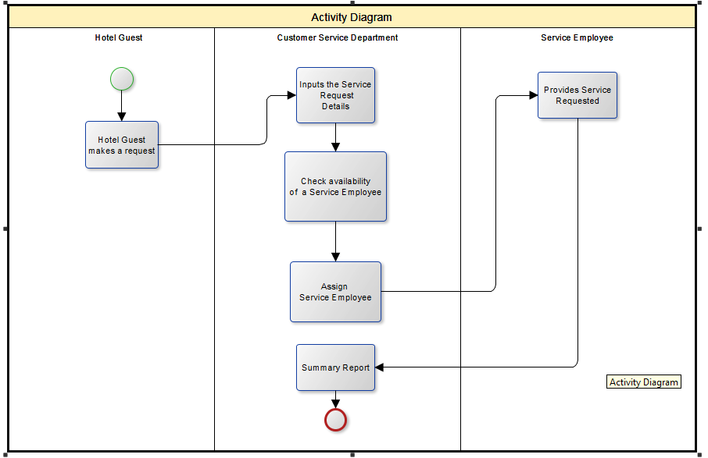

Figure 4: Activity Diagram for the SM Hotels Service Request Management System

The activity diagram shows that when a hotel guest makes a request for a service, the requested service details will be received by the Customer Service Department, while preparing the requested service a staff will check the availability of a Service Employee then if there is an available Service Employee the Service Employee will be assigned to provide the requested service by the Hotel Guest. The Service Employee also needs to provide a summary report after providing the requested service.

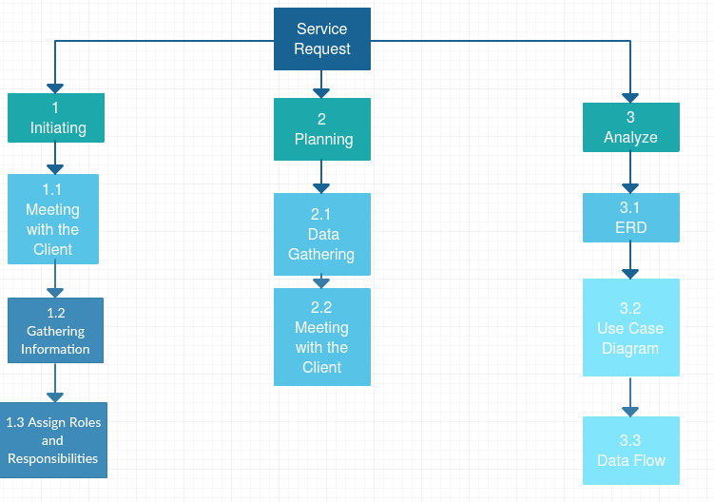**4.5 Gantt Chart and WBS**

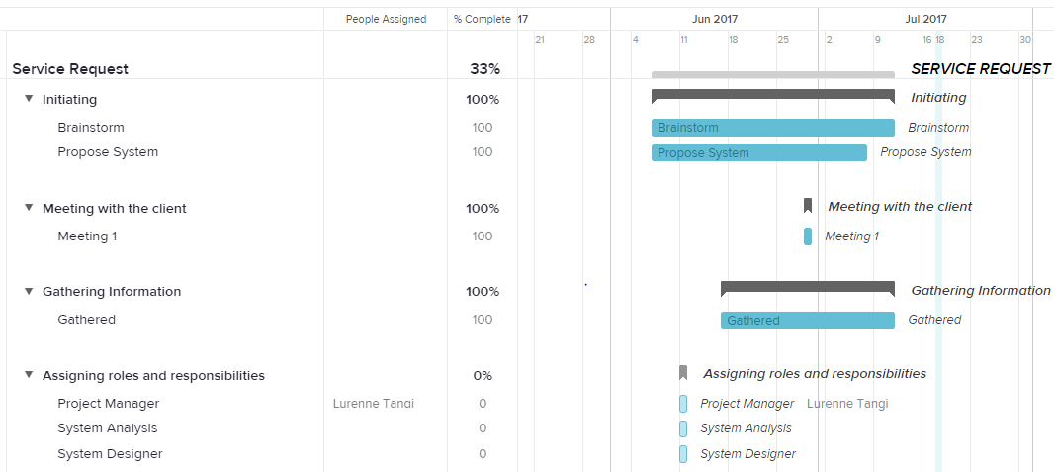

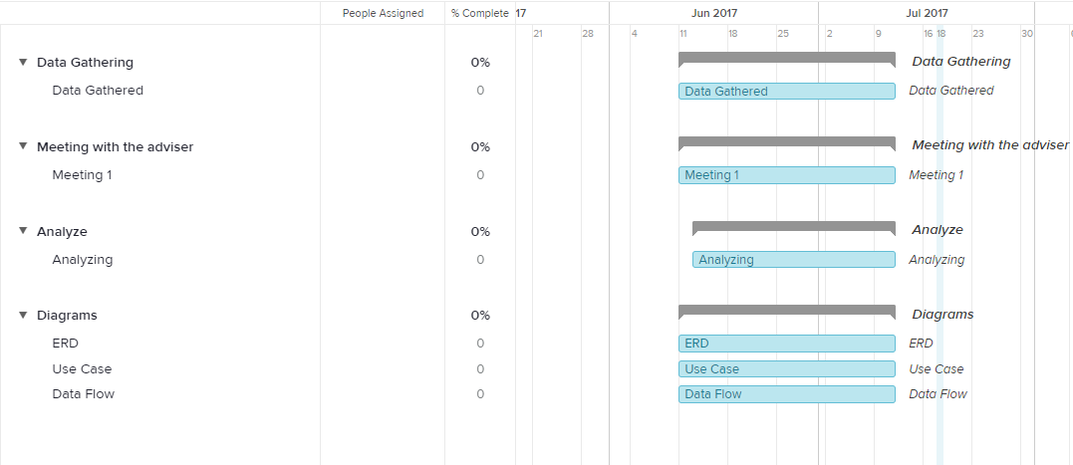

**4.6 Gap Analysis**

|  |  |  |
| --- | --- | --- |
| **User Requirements** | **Current System** | **Proposed System** |
| **Assigning of employees to execute task should be automated** | Manually needs to find an available service employee | The system will show only the current available employees |
| **The operator and the customer service department can see the details and the status of the requested service.** | Needs to rely on the assigned service employee | A dashboard that will show the on-going and pending service request |
| **A system that can record summary reports** | Reports are done through Microsoft Word and they are not sorted out | The reports will can be easily input into the system by importing the Word document or typing out the details in the automated form |
| **Request preparation should be fast** | There are no current accurate list of currently available service employee | All available service employee will be sorted out in the system |

References

Know Cross (2017). Know Cross Service [online]. Available: http://www.knowcross.com/know-service/ (2017)

Oracle (2017). Oracle Hospitality for Hotels – Opera Property [online]. Available: https://www.oracle.com/industries/hospitality/products/opera-property-services/index.html (2017)

Hotelogix (2017). Hotelogix Online PMS [online]. Available: http://www.hotelogix.com/ (2017)

eZee (2012). eZee PMS [online]. Available: http://www.ezeefrontdesk.com/ (2017)

Roommaster (2017). Roommaster inQuest software [online]. Available: http://roommaster.com (2017)

Frontdesk Anywhere (2017). Frontdesk Anywhere Hotel Management Software [online]. Available: http://www.frontdeskanywhere.com/features/hotel-management-software (2017)

HostPMS (2014). Hostpos [online] Available: http://hostpms.com/en/solutions/hotel-management-systems/hostpos (2017)

Guestline (2016). Rezlynx Guestline PMS [online] Available: https://www.guestline.com/products/operational-solutions/rezlynx-pms.html (2017)

ResortData (2017). RDPWin [online] Available: http://www.resortdata.com/rdpwin/ (2017)

Maestro (2015). Maestro PMS [online] Available: http://www.maestropms.com/?q=company-profile (2017)

Skyware (2009). Skyware Hospitality Solutions [online] Available: http://www.skywaresystems.com/about/index.html (2017)

Hoteliga (2014). Hoteliga [online] Available: http://www.hoteliga.com/en/faq (2017)

Clock (1996). ClockPMS [online] Available: https://www.clock-software.com/company-aboutus/index.html (2017)

Elina (2007). Elina Property Management [online] Available: https://www.elinapms.com/about-us/ (2017)

Genkan (2010). Genkan [online] Available: https://www.genkan.com.au/wp/genkan/history-genkan/ (2017)

CloudBeds (2017). CloudBeds PMS [online] Available: https://www.cloudbeds.com/our-story/ (2017)

ResOvation (2017). RezOvation Web [online] Available: https://www.rezovation.com/about

KWHotel (2017). KWHotel PMS [online] Available: http://kwhotel.com/en/about-us/

Bookalet (2017). BookaletPMS [online]. Available: https://www.bookalet.co.uk/aboutus (2017)

MagnaTimeshare (2017). Magna Timeshare Software [online]. Available: https://www.magnatimesharesoftware.com/about-us/ (2017)

SistemHotel (2005). Sistem Hotel PMS [online]. Available: http://www.sistemhotelsoftware.com/ (2017)

OpenHotel (2017). Open Hotel PMS [online]. Available: https://openhotel.com/pms.cfm (2017)

Smart Hotel (2017). Smart Hotel Software [online]. Available: http://www.smarthotelsoftware.com/html/support.html (2017)

Ibelsa (2017). The All-in-one PMS [online]. Available: https://www.ibelsa.com/en/help-support/overview/ (2017)

Kott (2017). Hospitality Management [online]. Available: http://www.kottsoftware.com/About/GEN-About.aspx (2017)

Capterra (2017). Keepmebooked PMS [online]. Available: http://www.capterra.com/hospitality-property-management-software/spotlight/101333/Keepmebooked/Keepmebooked (2017)

Hoteline (2017). HotelinePMS [online]. Available: http://hotelline.biz/ (2017)

Rezserve (2004). Rezserve PMS [online]. Available: http://www.rezserve.com/our-team/ (2017)

Rezware (1992). IRez [online]. Available: http://www.rezware.com/about.html (2017)

Monkport (2017). Monk HMS [online]. Available: http://www.monkport.com/hotel-management-software.html (2017)

Winsar Infosoft (2015). WinHMS Express [online]. Available: http://www.winhms.com/aboutus.html (2017)

Hallisoft (2015). RezEasy Cloud PMS [online]. Available: https://hallisoft.com/RezEasy_Cloud/ (2017)

Ipo-software (2017). I-Pro Booking System [online]. Available: https://www.ipro-software.com/about-us/ (2017)

Corrigo (2017). Corrigo CMMS [online]. Available: http://www.corrigo.com/about-corrigo/ (2017)

Mirage Hotel (1985). Mirage Hotel Systems [online]. Available:

http://www.miragehotelsystems.com/about-us-hotel-software/ (2017)

Ofek (1994). Guardian PMS [online]. Available: http://www.ofek.co.in/company.html (2017)

Protel (2017). Protel PMS [online]. Available: http://www.protel.net/company/ (2017)

HoteloPro (2011). HoteloPro PMS [online]. Available: https://www.hotelopro.com/reservations-management.html (2017)

Panstrat (2016). Hospitality Property Management [online]. Available: http://www.panstrat.co.za/about-us/ (2017)

SpringMiller (1984). SMS|Host PMS [online]. Available: http://www.springermiller.com/about/ (2017)

LittleFishcom (2000). ResortManager PMS [online]. Available: http://www.littlefishcom.net/About-Us (2017)

CMSHospitality (1983) GuestCentrix PMS [online]. Available: https://www.cmshospitality.com/about/ (2017)

ClerkHotel (2017). Clerk PMS [online]. Available: http://www.clerkhotel.com/management/ (2017)

Innkey (2017). Innkey PMS [online}. Available: https://www.innkeypms.net/Home/AboutUs (2017)

Mancloud (2016). ManCloud PMS [online]. Available: https://www.mancloud.eu/en (2017)

IHotellligence (2009). IHotel PMS [online]. Available: http://www.ihotelligence.com/index.php/sample-page/our-company/ (2017)